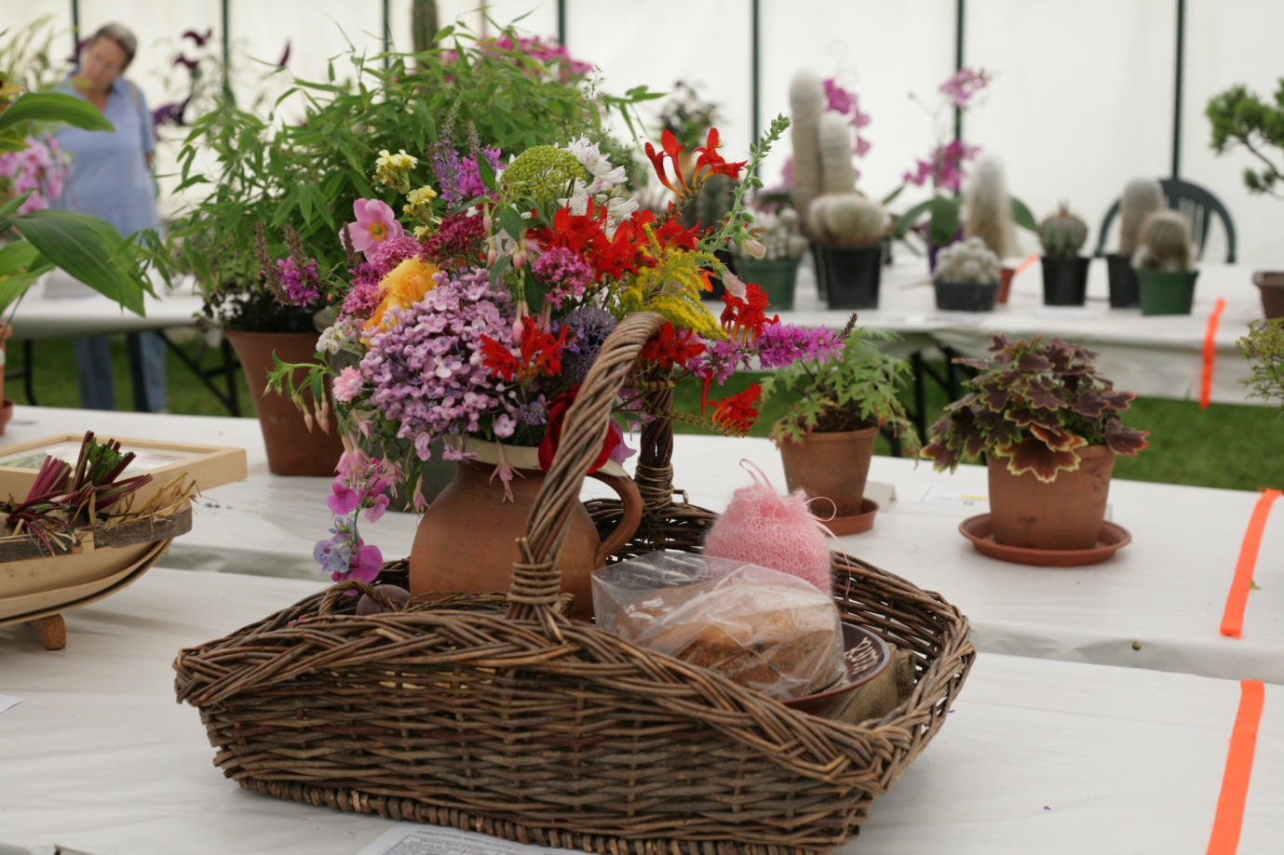A beginners guide to Showing at Portishead Summer Show

Have you been to our Show and thought you might like to enter but are not sure how to go about it ? Or have you seen a class where there were not many entries and your own produce looked a lot better? Then why not enter next years' Show.
The guide covers horticultural, floral, handicrafts, cookery and children's classes so please read the whole document.
We really want to encourage new exhibitors, especially those new to gardening and having an allotment. We specifically have Novice classes to encourage newbie's to enter safe in the knowledge they are being compared to other first time entrants, although you are more than welcome to enter the Open classes too. We have put this document together to help you by giving advice on how to enter and to give an insight into what the Judges are looking for. Whilst some of the suggestions may look a little daunting the comments are designed to help you present your horticultural, handicrafts and baking exhibits in the best light for judging.
Remember the more entries the better the Show and we have had novice entrants beat seasoned gardeners because on the day their produce was better!.
We have three class types -
- Novice for the first time entrants
- Members - restricted to current members of the Portishead Horticultural Society
- Open - open to all
A Novice entrant can enter the Open classes if they wish to. Remember also that there are specific classes for Senior Citizens - anyone over 60. These classes are often forgotten so it is always worth having a go if you are in this age range.
Note - Novices who win a first prize in a class one year cannot get a first place if they enter in the same Novice class in a subsequent year - this is because we really want novice entrants for each class type.
Planning Ahead
If you want to enter the next Show it is a good idea to plan ahead by selecting and ordering your seeds and plugs or by preparing your cuttings. The RHS website is a good source for finding the best vegetable varieties and cultivars.
You can find out details of the classes you can enter by looking at an old schedule or looking online at the pdf for the 2021 Show schedule on our web site - see www.portisheadsummershow.com - Competitive Class Entries.
Please note that we do change some classes but the vast majority, particularly the vegetables and flowers remain unchanged from one year to the next.
Please note one of the regulations specifically requires you to have had and grown plants for a minimum of 6 weeks before the Show.
Don't enter too many classes your first year, it takes a long time to gather, inspect, choose and stage each exhibit well. Remember you might also need some floral foam or chicken wire to hold your flowers in place. You might find it useful to have some raffia and sand to prepare and show some vegetables in addition to some black cloth to act as a backdrop to some vegetable classes.

Horticultural Classes
Choosing your exhibits:
• Judges are looking for vegetables, fruit, flowers, etc in excellent condition, that are the most uniform in size, shape and colour and award points accordingly, using a score chart - see over. Uniformity in size is more important than impressive size unless the class calls for ‘largest’, ‘heaviest’, etc. As you can see the chart shows that for Tomatoes the Judge awards a maximum of 18 on the basis of: Condition 5, Uniformity 4, Shape 3, Size 3 and Colour 3.
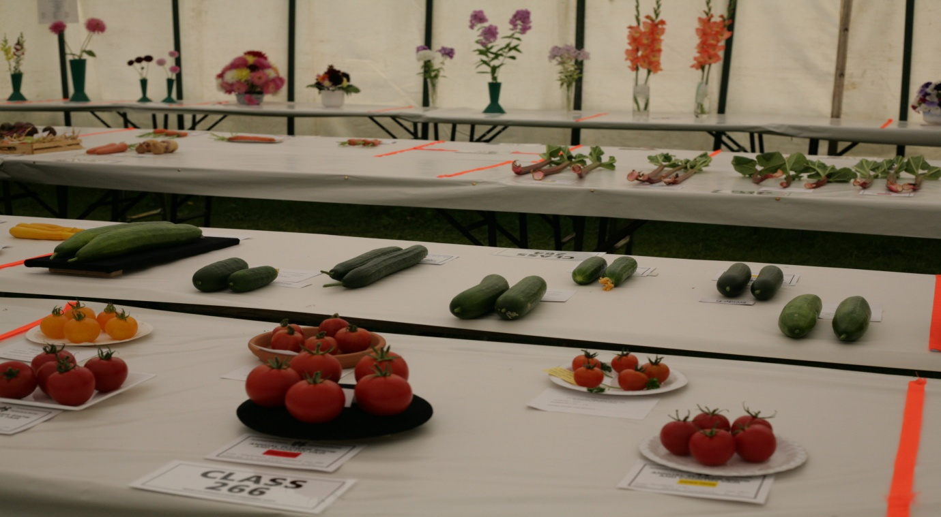

.
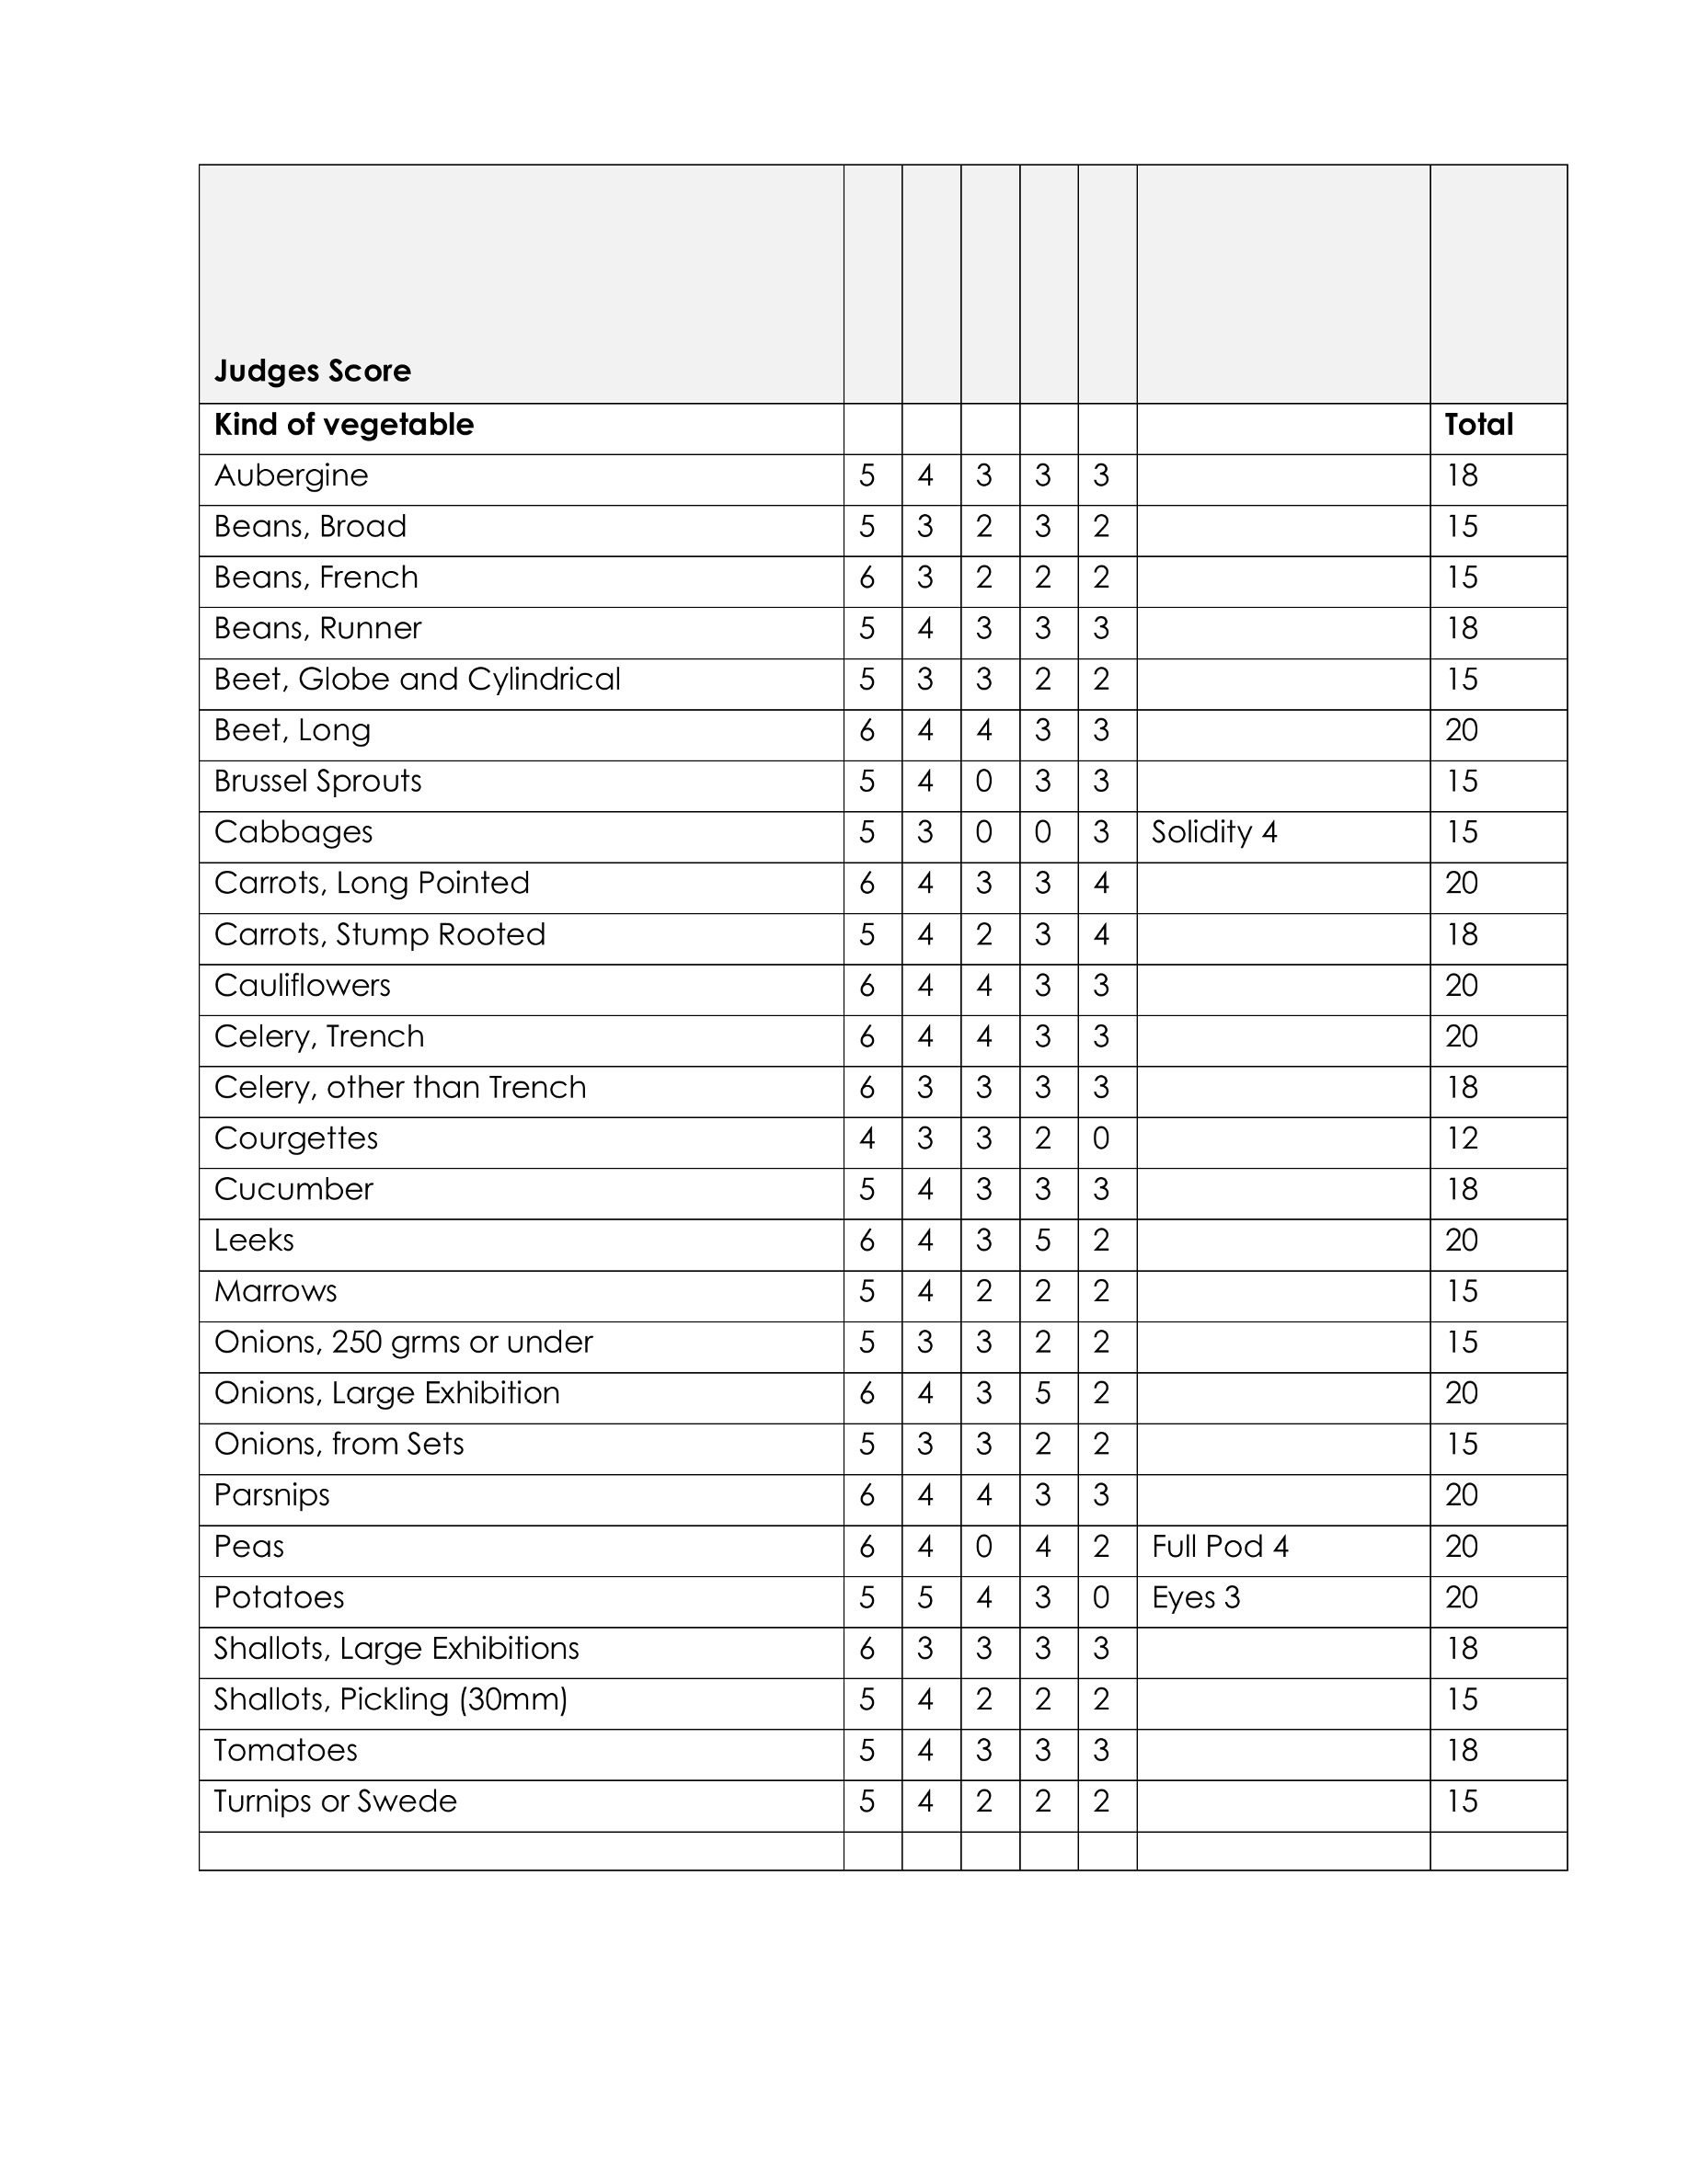
Preparation of exhibits:
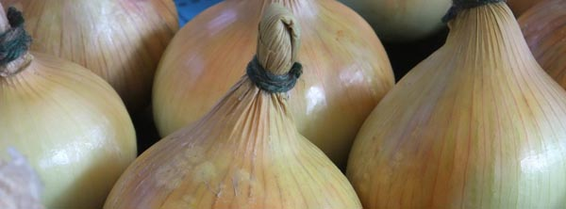
• Keep your produce well watered as show day approaches so that they will be at their best when you pick them
• Fruits and vegetables should be ripe for eating – do not choose under ripe or over ripe specimens.
• Exhibits should be free from any defect such as disease, insect infestation and damage, for example from garden tools.
• Collect your specimens as near to show time as possible – the fresher they are the better they will look on display. Storing in the fridge will help to preserve their freshness until it’s time to exhibit.
• Specimens should be clean. Remove soil by brushing, washing or wiping gently. Avoid scrubbing as it can damage the surface.
• Where applicable, handle fruits and vegetables as little as possible to avoid damage to any natural bloom.
• Aim to make your exhibits look attractive with a neat symmetrical display, e.g. in a ‘wheel’ formation for peas, tomatoes, etc; in rows for beans; in a fan shape for carrots. Align stalks towards the back of the table.
• Pay attention to whether the schedule asks for a ‘plate of’ or ‘dish of’ as your exhibit might be disqualified for use of the wrong type of container. If no container is specified, you can lay your exhibits directly onto the table.
• Root vegetables – beetroots, carrots, parsnips, etc - must have the leaves cut so that approximately 75mm of leaf stalk remains, which should be neatly tied. Apart from improving the presentation of the roots, this helps to make the exhibits anonymous as far as the judge is concerned. Water the soil before lifting to minimise damage to the root. Take care when washing as any damage will show clearly after a few hours.

• Runner Beans should be exhibited with some stalk (the handle) attached. They should be straight and of equal length and uniform size and of a good even colour and free from blemishes. The seeds should not be overly prominent in the pod (the judge will snap one of your beans when judging to check that they are fresh and not stringy)
• Onions should be uniform in shape and size and have the top(neck) tied and bound neatly with raffia. They are often staged on rings or soft collars so that they sit upright (you can use cardboard tubes from used kitchen roll cut to size for this). Pickling onions must not exceed 30mm in diameter, the necks should not be tied and they should be neatly presented on a plate of clean dry sand.
• Potatoes should be as far as possible of the same shape and size with eyes that are shallow and free from blemishes. Wash very carefully in clean water with a soft sponge – avoid use of a coarse cloth or brush that might damage the skin. Select medium sized specimens, generally between 175g and 225g. The presence of green colouring as a result of exposure to light is considered defective.

• Tomatoes should be staged on a plate with calyx intact and uppermost. A small amount of sand on the plate can help to settle the fruit upright. You can find examples on the web of how things should be presented.

• Cabbage should be of a good size and colour and have a firm solid heart. The leaves as far as possible should be clean and free from slug and caterpillar damage - best to check there are none lurking in the foliage. The roots should be cut off as can some outer leaves if they are damaged but do not remove all leaves and there should be a neat stalk of some 75mm. The cabbage should be fresh.

• Beetroot when taking this from the soil be careful to try and maintain a long tap root. You can do this by watering well and easing them from the soil. Carefully trim any side roots from the main tap root. The beetroot should be carefully washed with a soft cloth to ensure they are earth free. The ideal size of the beetroot should be that of a tennis ball. The leaf stalks should be cut to a length of 75mm and tied with raffia.

• Courgettes should be fresh and between 4 and 6 inches in length and of a uniform shape and size with good skin colour and without blemishes. The flowers can be left attached but this is not a must. Do not cut the courgettes too close to the fruit and as they should have about 2cms of stalks attached.

• Cucumber should be exhibited with about 2ms of stalk attached and with the dead flower intact and still attached at the end of the cucumber. It should be clean, fresh, straight and not over mature.

• Tomatoes should be staged on a plate with calyx intact and uppermost. A small amount of sand on the plate can help to settle the fruit upright. You can find examples on the web of how things should be presented.

• Apples and Pears should be staged with stalks attached and the fruit should not be polished. The fruit should be uniform in size and shape with skins free from blemishes, patches of discolouration and bruising. Specimens should be fresh but ripeness of fruit is not so important.

Flower Classes
The information presented here is based on text from 'The Horticultural Show Handbook' (Royal Horticultural Society, 2008) and is used with permission.

Mixed Flowers and other Cut Flower Classes (Roses, Dahlias, Daffodils, etc):
Flowers that are arranged symmetrically and face the judge square on are always going to be noticed more than those that twist away so rotate the flower head so that symmetry is achieved.
An exhibit that has 2 or 3 leaves in the vase will (providing it is neatly ‘staged’) normally prevail over an exhibit of equal quality that does not have foliage.
Choose exhibits that are in good condition, that is, when they are at their most perfect and all parts are fresh and free from damage due to weather, pests, diseases, careless handling
In vases of one kind of flower, choose exhibits that are the most uniform, that is, when they are most alike in age, size and form.

.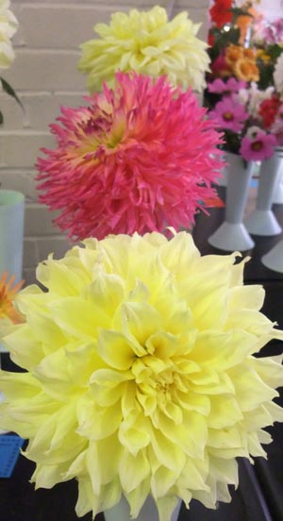

Floral Arrangements:
• Make sure you interpret the title of the class you are entering and use appropriate plant material for that class
• Keep within the measurements allowed
• Condition your plant material thoroughly i.e. gather foliage 24 hours beforehand and stand foliage and flowers in buckets of cool water in a cool place
• Ensure your plant material is in peak condition and there are no damaged leaves or blooms
• The RHS 'The Horticultural Show Handbook' suggests "Beauty of form and colour, lightness of arrangement, happy harmonies or suitable contrasts always meet with general approval. The use of suitable foliage, berries, fruits and seed pods, and accessories may be desirable and permitted or required by the schedule."
Pot plants including Cacti and Succulents:
Please ensure that the pot size is correct for the class.
• The exhibit should be large for the particular type of plant, well-balanced in shape and in good health.
• Plants should have healthy unblemished foliage (and flowers in the flowering plant classes).
• Cacti/succulents should be as free as possible from defects, including damaged or missing spines, distorted bodies or leaves, abnormal marks, etc.
• Pots or containers should be clean and undamaged. Any staking should be neat and should not detract from the appearance of the plan

Cooking Classes
Careful attention should be paid to the instructions/recipes - particularly cake tin sizes and jar specifications.

• Cakes should be well risen, even in shape and baking. Any fruits should be evenly distributed throughout the cake. A domed top with slight cracking is acceptable for light fruit cakes. The cake should not bear any cooling rack marks.

• Preserves - use clear jars free from commercial trademarks with unmarked lids. All preserves should be labelled with small labels stating the main fruit used together with the day, month and year of making.

• Jams, Jellies and Marmalades - use clear jars free from commercial trademarks with unmarked lids. The jar should be filled to the brim to allow for shrinkage. For the top of the jar use a well fitting wax disc and cellophane or a new twist top.
Handicrafts
As previously stated read the schedule carefully and ensure that you are entering the correct item in the correct class.
The Judges will look at the overall look of the craft, its finish, tension (where appropriate) and originality and this will be compared with the other exhibits in the same class. Please bear in mind that the item will be handled by the Judge.
Credit will be given for the use of different techniques and creativity.
Children's Classes
These are extremely popular, we have something for pre-school and under and for children under 6, 9, 12 and 16 years of age. We often find that the parents of current exhibitors used to exhibit themselves when they were younger so they know how exciting it is to win a prize!.
Children can be very creative so we would recommend that you get your child to pick the classes they want to enter a few weeks before the Show, this will give them (and you as you might need to make purchases) time to prepare their exhibit or exhibits if entering more than one class.
Whilst parents can help their children with their exhibits we do ask that it is limited as the Judge for these classes used to work in a Children's Nursery so will know what a child of that age is capable of.
Photography Classes
These are very popular and there are usually a mix of colour and black and white or sepia classes to enter. You must ensure that your photograph matches the size stated 5" x 9" or 10" x 8" (this can include a small border). We do suggest you use photographic paper not photo copy paper as the quality of the photograph is unlikely to match those of other competitors who use quality photographic paper.

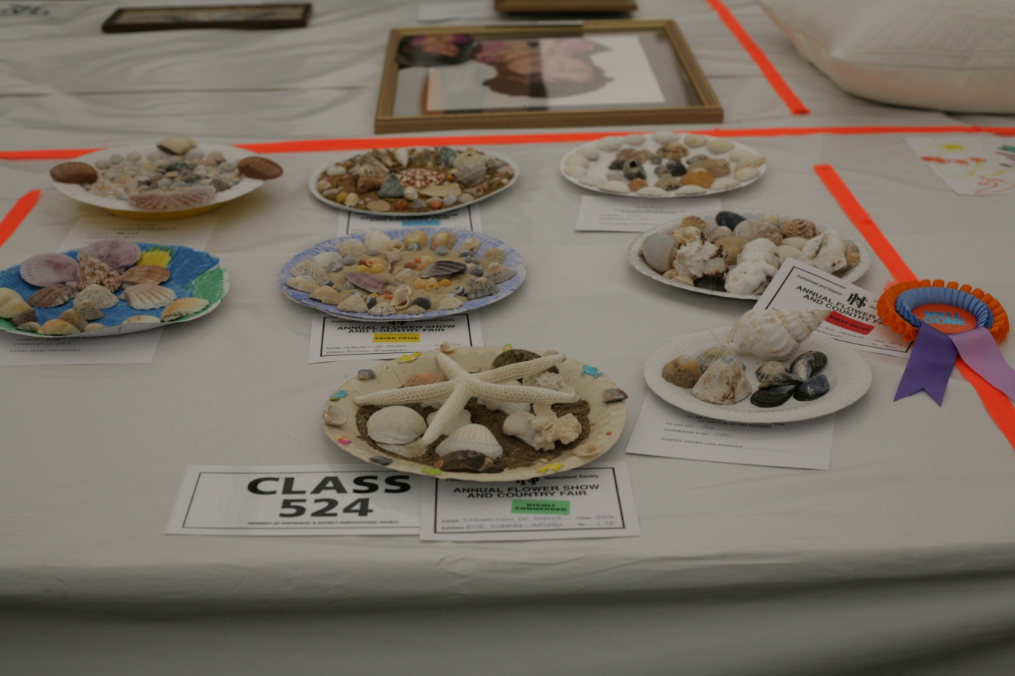

COMPLETING YOUR ENTRY FORM AND WHAT TO DO AT THE SHOW
Read the schedule (entry form) carefully!
Complete the entry form and take to the designated area or Show Field on the dates and times specified in the Class Schedule. Alternatively you can post to the person nominated in the schedule. Remember last entry time for submission of the entry forms for horticultural classes is 7.00pm on the Tuesday before the Show.
Follow the rules – if the schedule calls for five specimens, do not enter four or six. No one wants to see the dreaded NAS (not as per schedule) on their class card
Protect your exhibits well on the way to the field – it’s amazing how much they roll around in a car even at 5mph! A good tip is to keep some plastic milk bottles and pack them tightly into a box and then put your flowers in these to keep the heads tidy and separate.
Arrive in time to stage your exhibits. The Horticultural marquee is open to exhibitors on the Friday from 6.00 to 10.00 pm and 07.00 – 9:00 am on the Saturday..
When you get to the field with your items, go to the Office to pick up your entrant tickets. There will be one ticket to place by each of your exhibits. The class card should be put under the exhibit upside down so your name cannot be seen by the Judge. If you are unsure what to do, ask one of the other exhibitors or a committee member (wearing badges) who will be happy to help.
The marquee closes at 9.00 am for judging on the Saturday and reopens to the public at 12.00pm noon (or when the Show opens) for viewing.

Finally - GOOD LUCK !!!

